PROJECT REPORT

Preparation and Maintenance of ZOHO Books for Health Hub Medical CLINIC

TEAM MEMBERS

**M. MURSHITHA MADHINA [TEAM LEADER]**

**R. JOSHPIN MINI**

**M. LABEBA**

**R. MEENA**

**_________________________________________________________________________________________**

Health Hub Medical Clinic, a healthcare facility, relies on ZOHO Books to manage patient billing and invoicing. They can track medical service fees, manage insurance payments, and generate statements for patients. ZOHO Books helps them maintain financial transparency and ensures efficient billing processes

TASK-1 [EMAPTHY MAP]

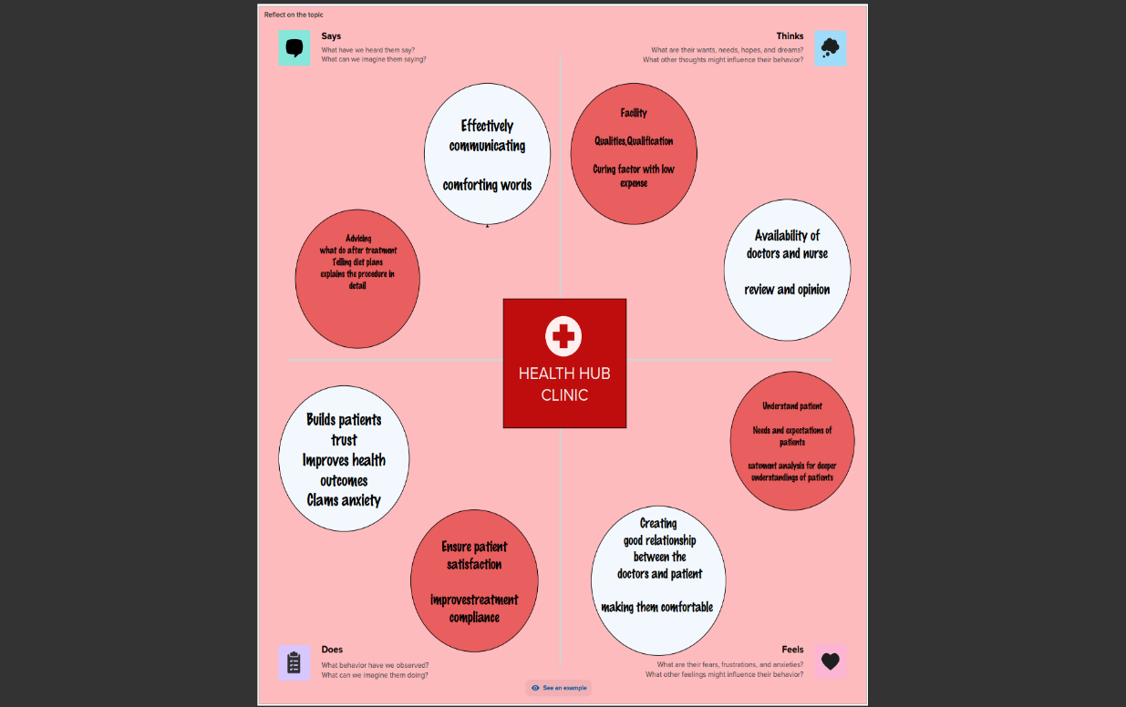

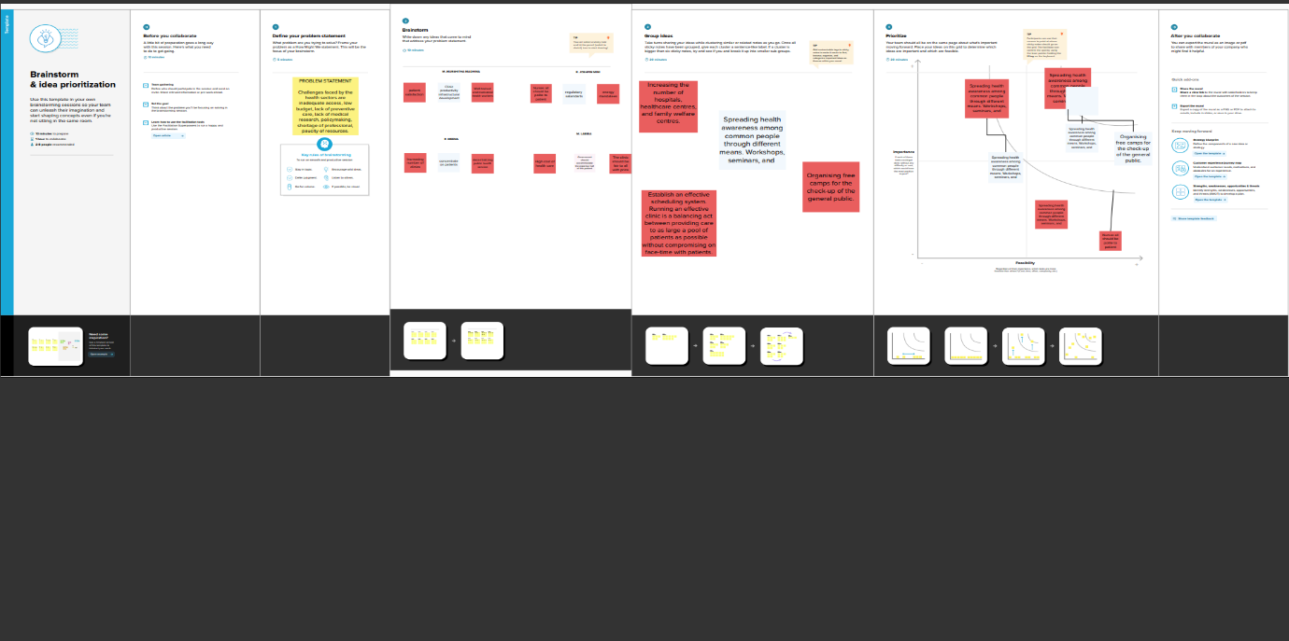TASK-2 [BRAIN STROMING]

Project Flow: To accomplish this, we have to complete all the activities listed below,

**PROCEDURE**

• Set up your account Sign up for a Zoho Books account and log in o Introduction Lets Get Started

• Services o Creation Review

• Vendors o Vendor Creation Review Vendors list and details

• Purchases Purchase order Creation (PO) o PO to Bill Convertion o Purchase Bills Creation Payment Marking to Purchase Bills

• Customers o Customer Creation Review Customers list and details

• Sales- Sales Order Creation (SO) SO to Invoice Convertion o Sale Invoice Creation Receipt marking to Sale Invoice

• Banking o Adding Bank Account

• New Accounts & Ledgers o Creation of New Accounts & Ledgers

• Journal Entries o Recording Journal Entries

• Expenses Recording Expense Bills

• Bank Transactions Recording Bank Transactions

• Financial Reports Balance Sheet o Profit and Loss GSTR-3B TDS Reports o Journal Reports Accounts Receivables o Accounts Payables

Financial report

# Profit and loss account

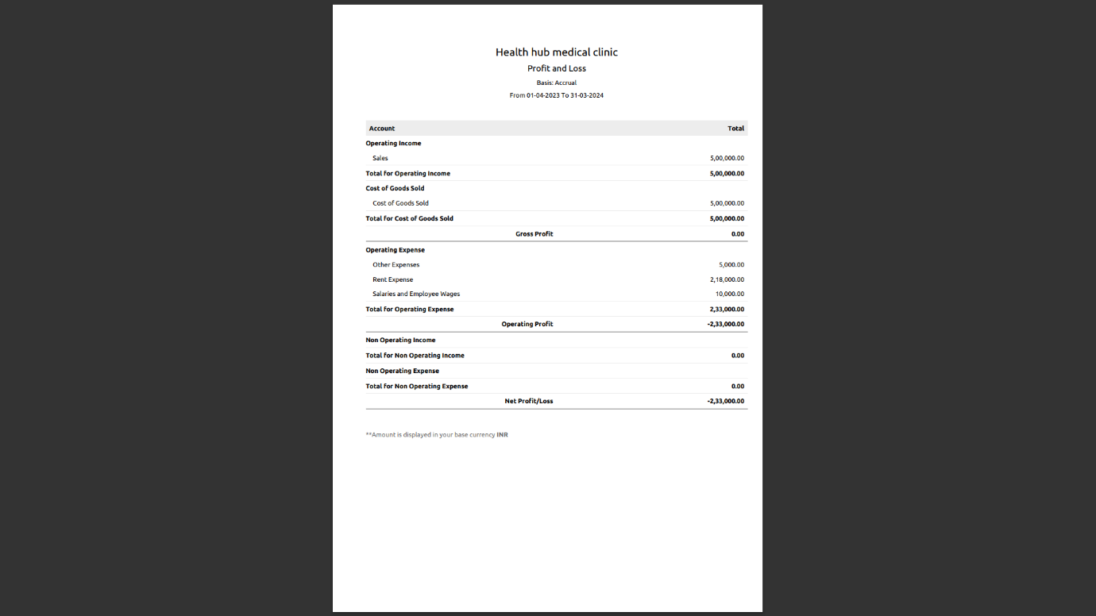

# Balance sheet

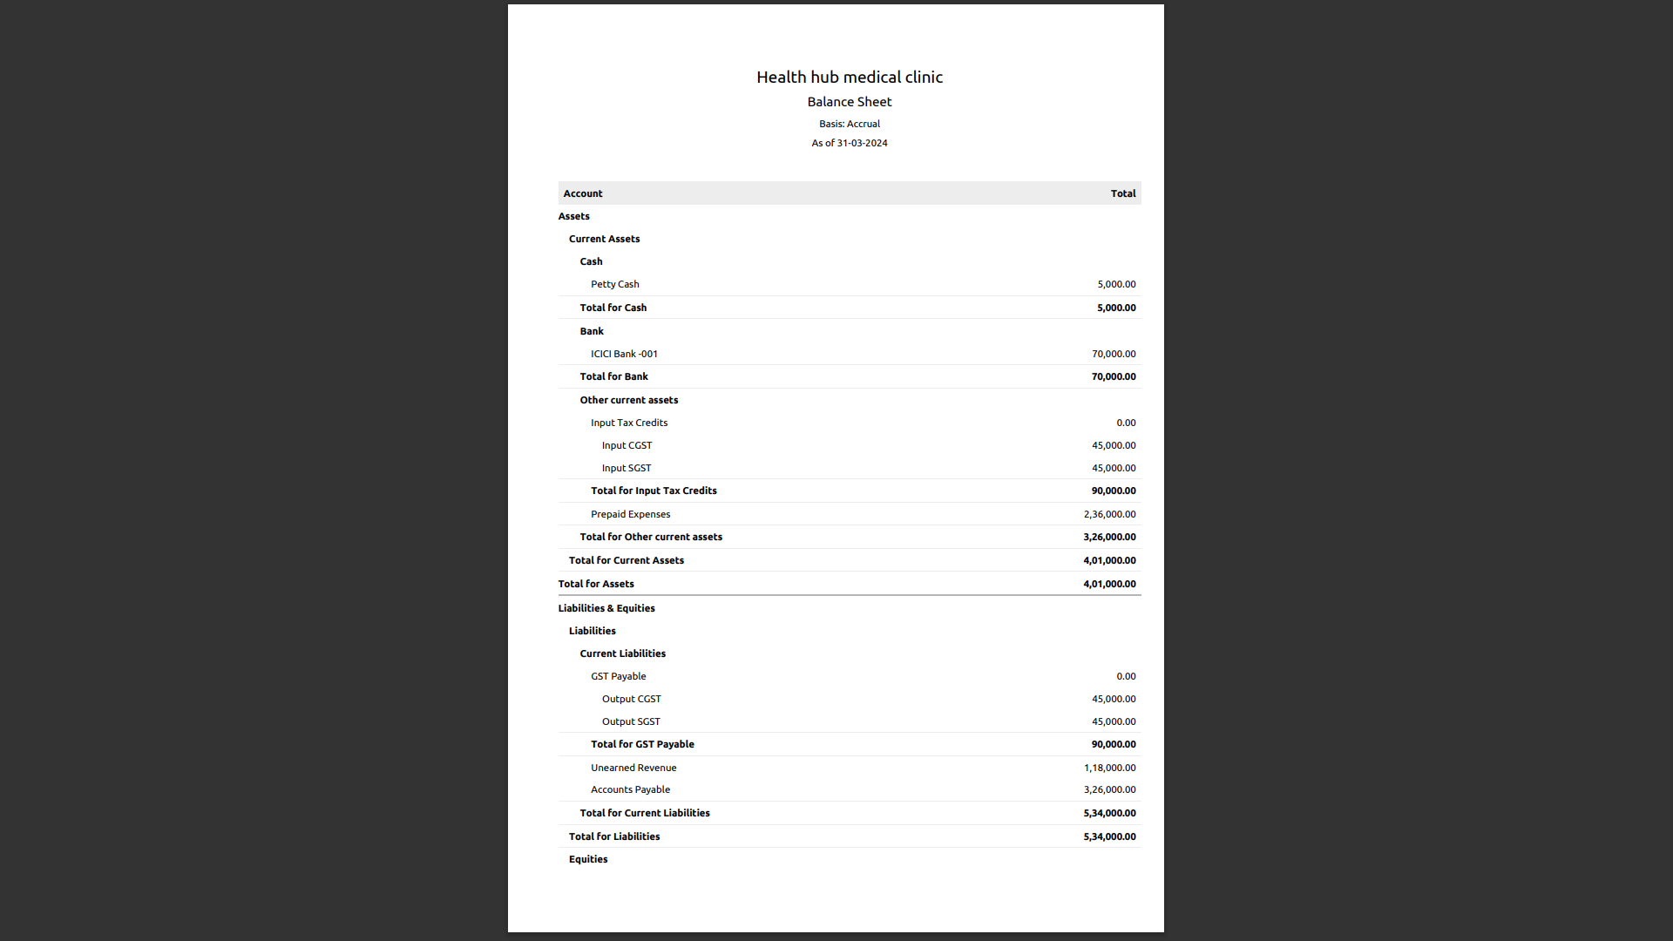

x-----------------------------------------------------------------------------------------------------------------------------------x